HERITAGE STATEMENT

MIDGELAND FARM, MIDGELAND ROAD, BLACKPOOL

Introduction

Midgeland farmhouse is of a linear plan and is depicted on the Great Marton tithe map of 1839 which shows a single range approximating the farmhouse, stable, barn and two adjoining shippons extant today. Historic mapping shows the development of the farm complex which has included the addition of a group of detached pig sties to the rear of the farm by 1893, 20th century additions to the rear of the farmhouse and the addition of an implement shed to the west of the farm buildings by 1938, and the addition of a new large shippon and a barn to the south west of the farm buildings during the mid and latter half of the 20th century. The farmhouse and buildings have been unoccupied and disused for a number of years and have deteriorated significantly. They stand within the perimeter of a former landfill site owned by Lancashire County Council (LCC).

The site comprises a four-bay two-storey hand-made brick-built farmhouse with porch at the east end with a former stable latterly converted into a garage occupying its west bay. This is built up against a cobble-built barn patch-repaired with brick, with two brick and cobble-built shippons at the west end. The farmhouse and stable is rendered beneath a thatched roof covered by asbestos sheeting. Significant amounts of the thatch and asbestos sheeting are now missing above the first bay of the farmhouse allowing water ingress. Internally the former stable converted into a garage has been extended into the barn. There is a hayloft to the upper floor. The barn has a roof of asbestos sheeting and a brick porch addition on its south side.

Background research

The area surrounding Midgeland farmhouse was originally wetland where only drier ridges could be cultivated for settlement. “The largest ridges were located where Great and Little Marton and Lytham now stand, but there were also smaller areas of dry land around Walkers Hill, Peel Hill, Midgeland Farm, Marton Fold and Blowing Sands. It is to these areas that early occupation sites are most likely to be found”. The discovery of a bronze axe at Midgeland Farm confirms this.

However, current knowledge about the age and historic development of Midgeland Farm itself is patchy. Some local history websites claim that the farm dates from the sixteenth century. Primary sources to verify this have not been forthcoming, although Myggland is marked on a c.1530 map in the National Archives. Whether this was a farmstead or simply an area of mossland is not known at present. Marton Moss and Its Neighbours by the late local historian Harold Monks states that the “origin of Midgeland Farm is obscure … Thomas Wilson’s map, drawn in 1773 for the Lord of the Manor, suggests that by that time the Moss was substantially drained … but devoid of buildings except at two locations – two dwellings on ‘Inclosed Land belonging to Christopher Hull and others call Stockidale’ and one farmhouse on ‘Inclosed Land belong to Christopher Hull of Midgeland” .

Eighteenth century parish records for the Hull family indicate that they were living at Midgeland in 1746 but again it is unclear whether this was the mossland area known as Midgeland or the site of Midgeland Farmhouse. Rapid desk-based research at Lancashire Archive suggests much more could be revealed by studying the Clifton archive, and the archive for the Fleetwood Hesketh family, who were formerly Lords of the Manor. It is understood that there is also an archive of Clifton papers at Lytham Hall. (The Clifton family at Lytham Hall bought the farmhouse in 1806, and Robert Hesketh was the Lord of the Manor in 1773). Many other documents may reveal further information about the site, for example, Lancashire Quarter Sessions papers DDC1/694 and DDX 1286 acc 4359B dated 1767 describe the enclosure awards for the area (not yet seen).

The farmhouse is shown on the 1816 land ownership map for Great Marton, and the footprint today is slightly different at the east end. This may suggest that at this point in time the farmhouse was originally a Fylde longhouse, and would have been single storey and built from cobble or cobble and cob. If archaeological investigation reveals this to be the case, this would be an exceptionally rare survival in this area, and the archaeological potential for understanding the construction of this building is, therefore, very high.

By 1816 the farm was owned by the Clifton family, and it is known that they altered other farmhouses in their ownership to improve the living accommodation. It is suggested here that the farmhouse was rebuilt around this time in the Fylde farmhouse style in handmade brick with the addition of a porch, a favoured design at this time, whilst retaining the cobble built barn and other attached buildings. The internal layout of the existing building resembles early vernacular design with the insertion of staircases, which would originally have been accessed by ladders into the loft area. Unlike other ‘improved’ farmhouses which were usually roofed in slate, Midgeland retains its thatched roof which suggests it was one of the earlier sites to be altered. Sampling and analysis of the remaining thatch would assist in dating the structure.

In assessing the significance of Midgeland Farm it is useful to refer to the work of Richard Watson, a founder member of the Vernacular Architecture Group, now a thriving national organisation with regional branches. Traditional Houses of the Fylde is the seminal work on the early houses of the Fylde peninsula and was published by Lancaster University, written by Richard Watson and Marion McClintock, 1979, the drawings being done by Watson.

The book illustrates that there is a common house plan throughout Fylde, from north to south, irrespective of land or estate ownership. In the 18th century many existing houses were given specific front facades which reflected the estates to which they belonged, or responded to the fashion of the time, yet whether the house was built at that time or earlier, the plan is the same.
The three bay plan with baffle entry was the norm for a Fylde farmhouse. The front door is facing the main inglenook or chimney stack. The middle room has no ceiling, and lofts above the side rooms would have been accessible via steps or ladders. With the later insertion of stairs, a chimney stack and a ceiling, there would have been a secondary stair for servants to reach their quarters. The alignment of the rooms is probably related to the need for the buttery to be on the coldest side of the house.

The plan of Midgeland Farm is not in Watson and McClintock’s book, indeed many of the farmhouses featured there have since been demolished. It does, however, follow the traditional pattern. The front porch gives it the added interest of having the look of a Clifton farmhouse, being in proximity to Lytham Hall, and linked to it and the coast by numerous extant public footpaths.

The sketch below shows the plan form in 1952 with the late 19th century/early 20th century outshots.

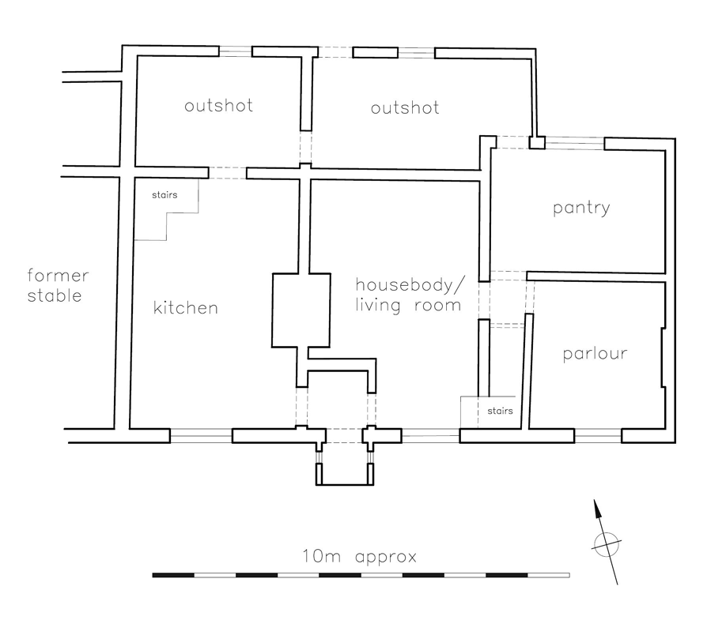
Source: Midgeland Farm, Marton: Proposed provision of bathroom, internal and external WCs with septic tank and ancillary works, Dec. 52 from Lytham Hall Archives, copied in Midgeland Farm Historic Buildings Assessment, July 2009, Stephen Haigh

Potential and opportunities

To date it has been impossible to date the age of the farmhouse and attached buildings with any accuracy. The Historic Buildings Assessment for Midgeland Farm carried out by Stephen Haigh in July 2009 for LCC states that the barn appears to be the oldest building on the site, which suggests that this was either originally the farmstead itself and the adjacent farmhouse was an early 19th century addition, or the living accommodation at the east end was partially or completely rebuilt in the 19th century. Either case clearly suggests that the building, in its relatively intact condition, is of at least high local significance and probably regional significance due to its rarity. (The Marton Moss Characterisation Report points out that surviving vernacular buildings are few in number, and are difficult to identify because of the degree of alteration). Besides the site’s archaeological potential, which should reveal its true age through dendrochronology and other methods, it also provides the opportunity for further archival research to improve our knowledge of the history of Midgeland Farm. Each of these pieces of work provides scope for learning and community engagement activities.

Heritage skills development

There is potential to develop the farm buildings as a training facility for traditional building skills in collaboration with, for example, Blackpool & the Fylde College and other training providers. Heritage skills are seeing greater demand and there is a shortage of young tradespeople coming out of college who can demonstrate, and are proficient in, these skills.

Marton Moss Characterisation Report 2009 Archaeo-Environment Ltd. P. 9
HER 45
Marton Moss and Its Neighbours, Monks. H. 1996, p. 61
Margaret Hull baptised 20.10.46. abode Midgeland
Great Marton Land Tax Appraisal, Lancashire Archive (insert archive no.)
St Annes on the Sea: A Local History Shakeshaft, P. p. 86
Archaeo-Environment Ltd., p. 58

