Council accused of failing to maintain rights of way in Blackpool

Residents are missing out on exploring Blackpool by foot because the council has failed to maintain public rights of way across the borough, it has been claimed.

By Shelagh Parkinson
Blackpool Gazette
Tuesday, 9th February 2021, 10:20 am
Updated Tuesday, 9th February 2021, 10:22 am
Signs are missing, access is blocked and some of the 47 rights of way in the town covering a total distance of 12km, even have buildings encroaching on them, councillors were told.
Ken Cridland told a meeting of the council’s tourism, economy and communities scrutiny committee, the council was breaching its legal responsibilities.
Addressing the committee on zoom as a member of the public, he said: “My wife and I tried to use path 11 to access Marton Mere.
“It starts on Preston New Road but is completely impassable because it has not been maintained for a long time. People have now started dumping things at the entrance.”
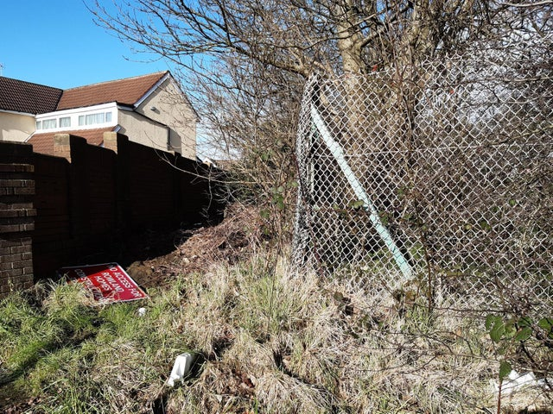The entrance to path 11 on Preston New Road
He added there were a number of rights of way on Marton Moss which also need attention with “at least four paths where undergrowth is a serious problem, two blocked by fences with no stiles or bridges, one blocked off by locked gates and two appear blocked by buildings.”
Mr Cridland said: “I’m afraid the council fails on every single legal responsibility on rights of way as I read it.”
Councils have a statutory duty to maintain public rights of way which includes keeping them in a fit state to use, removing obstructions, adding signs, working with landowners and protecting the public’s right to use paths.
Members of the committee, who also raised concerns over the issue, agreed to examine public rights of way as part of their scrutiny work plan.
Coun Paula Burdess said: “When we’re looking at green spaces and the active lives initiative, we could perhaps capitalise more on these 12km of rights of way.”
Coun Paul Galley said he had got lost during a walk to Marton Mere where there was “very poor signage”.
Coun Jim Hobson, cabinet member for the environment, said he had been unaware of the problem and pledged it would be looked at.
The 47 footpaths include routes around Blackpool and the Fylde College’s Bispham campus, near to Carleton cemetery, East of Stanley Park, towards Staining and around Marton Mere and within the Marton Moss area, towards the southern boundary of Blackpool.

